|  |  |  |  |  |  |
| --- | --- | --- | --- | --- | --- |
| S.NO. | NAME | UID | BRANCH | CONTACT | E-MAIL |
|  | Rohit Singhal | 18BCS3535 | CSE ( IS-1 ) | 8477877345 | rsinghal57@gmail.com |
|  | Yuvraj Thakur | 18BCS3521 | CSE ( IS-1 ) | 7018107703 | yuvraj491@gmail.com |
|  | Sarthak Rawat | 18BCS3530 | CSE (IS-1 ) | 9717738358 |  |

**THE PROJECT HAS HELPED TO SOLVE THE PROBLEM**:-

Paper piano will help to work as a stress reliever for children as an entertainment purpose. It may be used for recreational purposes as well. It has enhanced portability as compared to other pianos as it is light weight. Also, its cheap and can be used again and again.

**HOW WE ARE SOLVING THE PROBLEM:-**

The piano we have created will help as recreational purposes as it acts a toy or fun activity tool for the children. Also, it has enhanced portability because we have used light weight materials for the paper piano. Adding to the light weight, we have used graphite pencil which can be rubbed again and again hence decreasing and increasing the intensity of the pencil which will facilitate the working of paper piano.

**EXISTING STATE OF THE ART AND DRAWBACK IN EXISTING STATE OF THE ART**

|  |  |  |
| --- | --- | --- |
| S NO. | EXISTING STATE OF ART | DRAWBACK IN EXISTING STATE OF ART |
| 1. | The model consists of Arduino, PCB, Resistor , jumper wire(male to male), buzzer, paper clips , sketched paper. | Looks messy and not durable enough. |

**ADDITIONAL MODIFICATIONS THAT YOU CAN PROPOSE TO IMPROVE UPON DRAWBACKS:-**

1. We can improve its outlook by using cardboard to give our model a nice shape.
2. We can also paint it to make it look better.

**ADVANTAGES OF THE PROPOSED FEATURES:-**

1. Improving its outlook will help to increase its selling in the market because more people will be attracted to it.

**BLOCK DIAGRAM**

CAPACITIVE SENSOR

SPEAKER / BUZZER

**Materials**

* Male-to-male jumper wires
* Breadboard
* Arduino Uno
* Resistor 1M ohm
* Speaker
* Pencil
* A4 paper
* Paper clip

**STEPS OF CIRCUIT COMPLETION**

**1. SHADE / PAINT YOUR CIRCUIT :-**

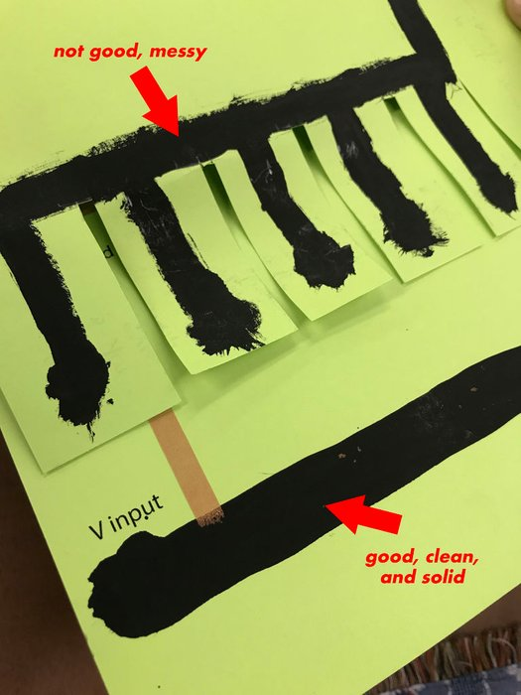

**2. ARDUINO :-**

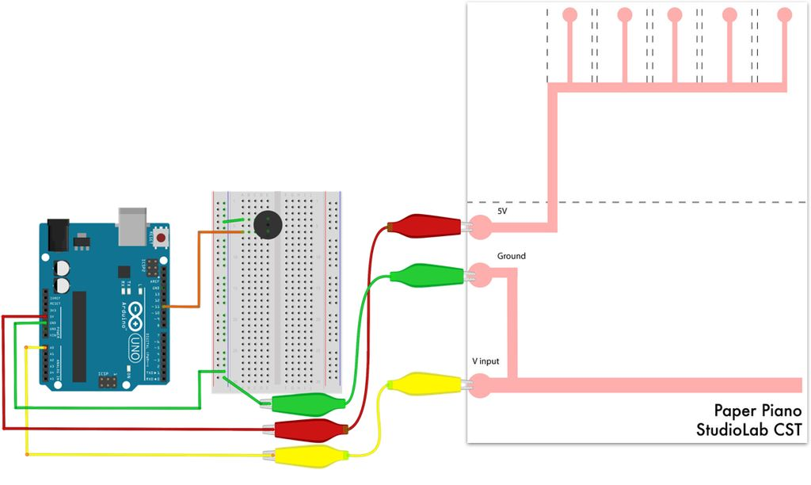

**3. CODE :-**

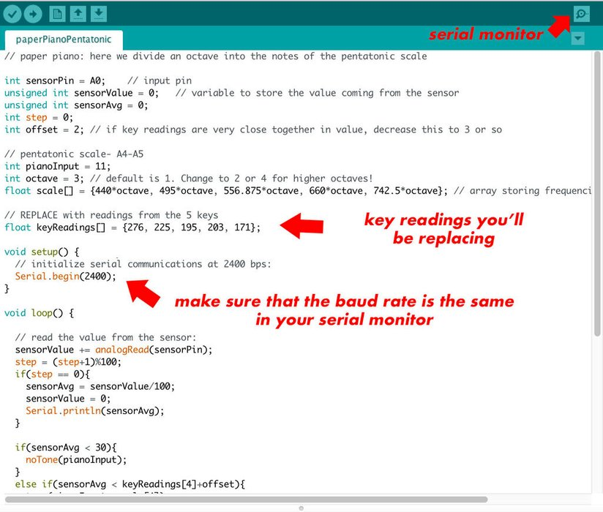

**PROGRAM CODE :-**

**https://github.com/rsinghal57/solid-memory**